SDPD Project Report

**Research Question:**

1) How would the officer’s experience and perceived gender affect the stop duration?

* Perceived gender and stop duration
* Experience and stop duration

2) Is there any correlation between action and race?

3) Is there any correlation between action and gender?

**Data Collection**

We collected and compiled the data for this research from the public website Data San Diego (<https://data.sandiego.gov/datasets/police-ripa-stops/>). According to the three research questions of our interest, we select and apply data cleaning on ripa_stops_datasd.csv, ripa_actions_taken_datasd.csv, and ripa_race_datasd.csv.

**Analysis**

Our analysis would only apply on Perceived Gender, StopDuration, Exp Years, Year from ripa_stops_datasd.csv, Action from ripa_actions_taken_datasd.csv, and Race from ripa_race_datasd.csv. We join these three data sources through assigning related fields. Before performing any analysis on the data, we exclude 152 null values in perceived gender in ripa_stops_datasd.csv using filters. We explore the relationship in each pair of features through visualization and interpretation.

**Observation**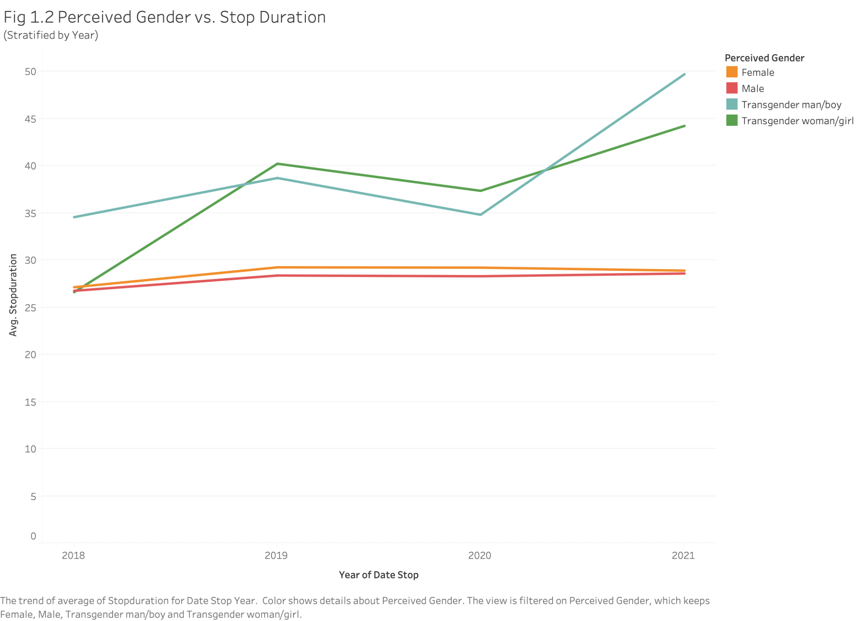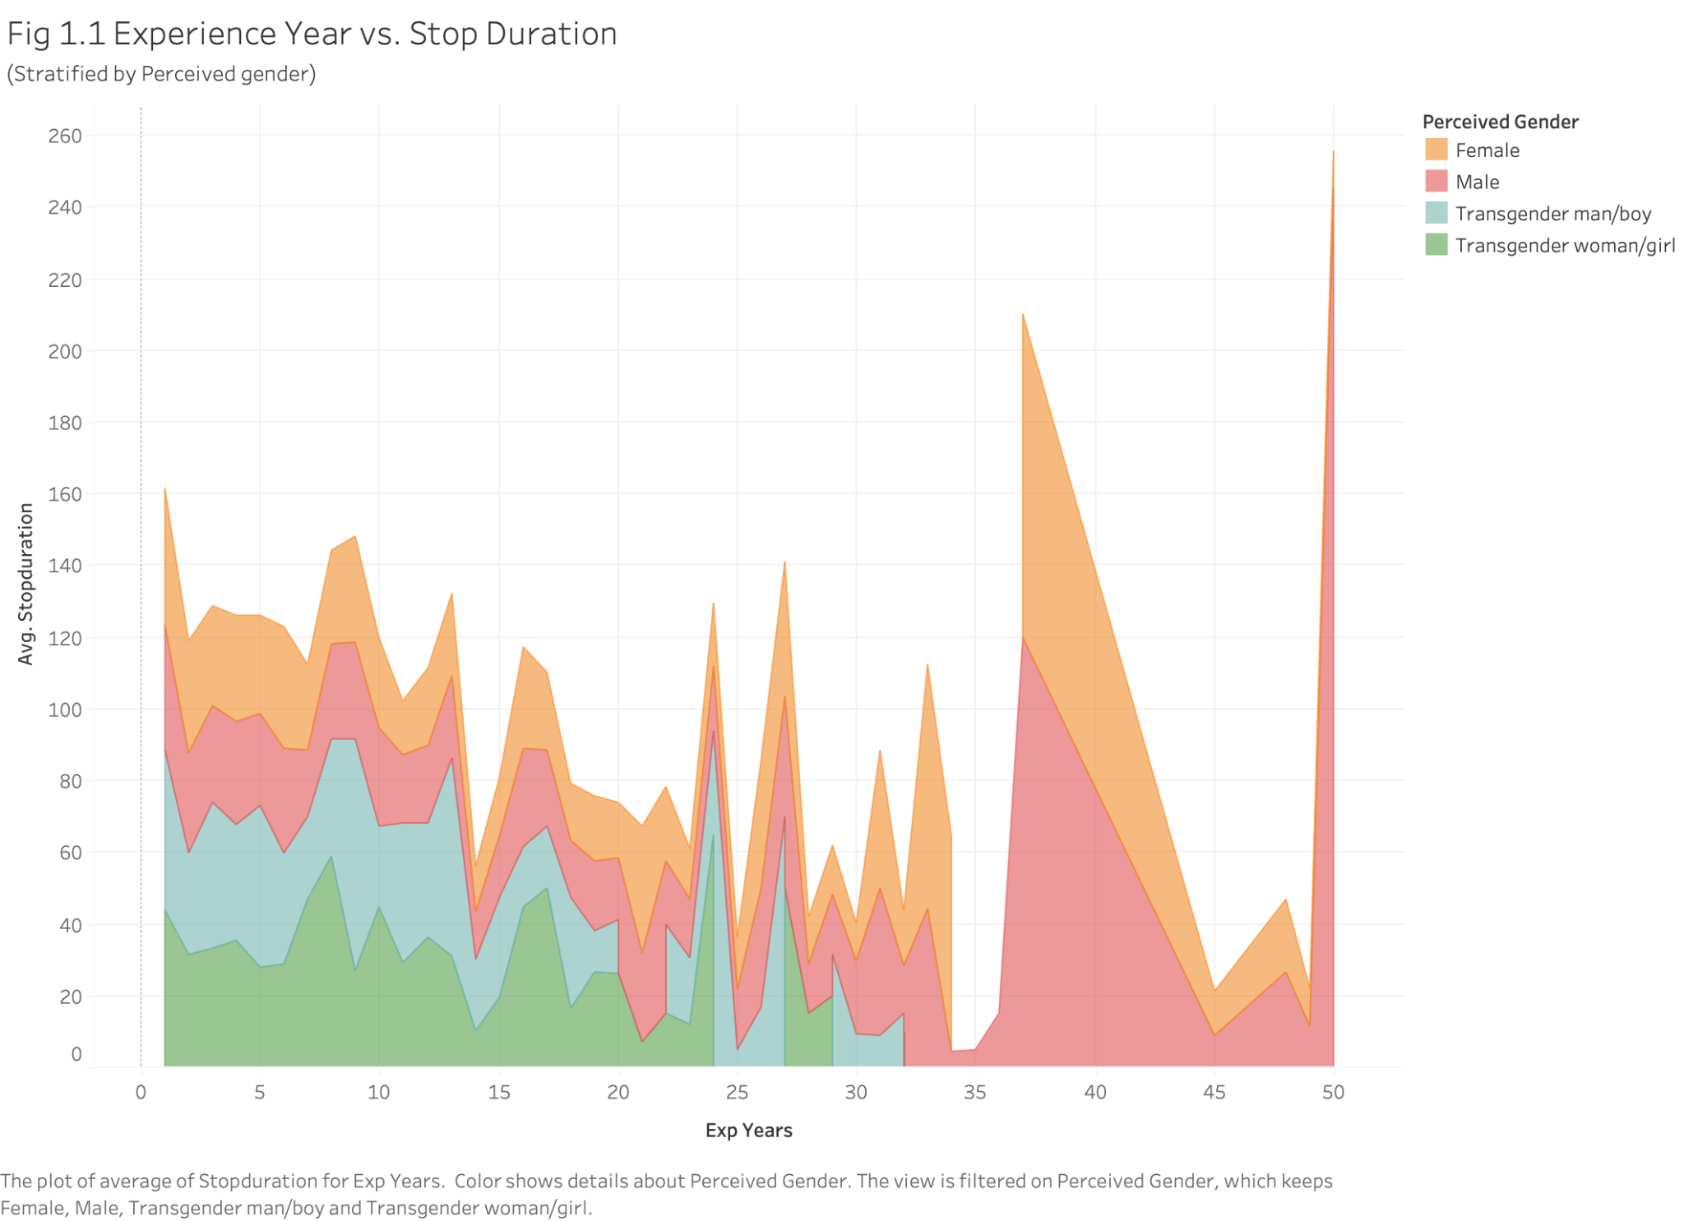

* There are potential outliers in stop duration of Perceived Male for officers with 37 and 50 years in Fig1.1.
* Fig 1.1 shows no stop duration record for people who are perceived as transgender when officers has 32+ experience years.
* Fig 1.1 reveals no or mild correlation between the experience years of the officer and stop duration.
* Fig 1.2 shows that people who are perceived as transgender tend to being stopped for a longer time than non-transgender people are.
* Fig 1.2 shows that there is an increasing trend in stop duration in general, for people who are perceived as transgender.

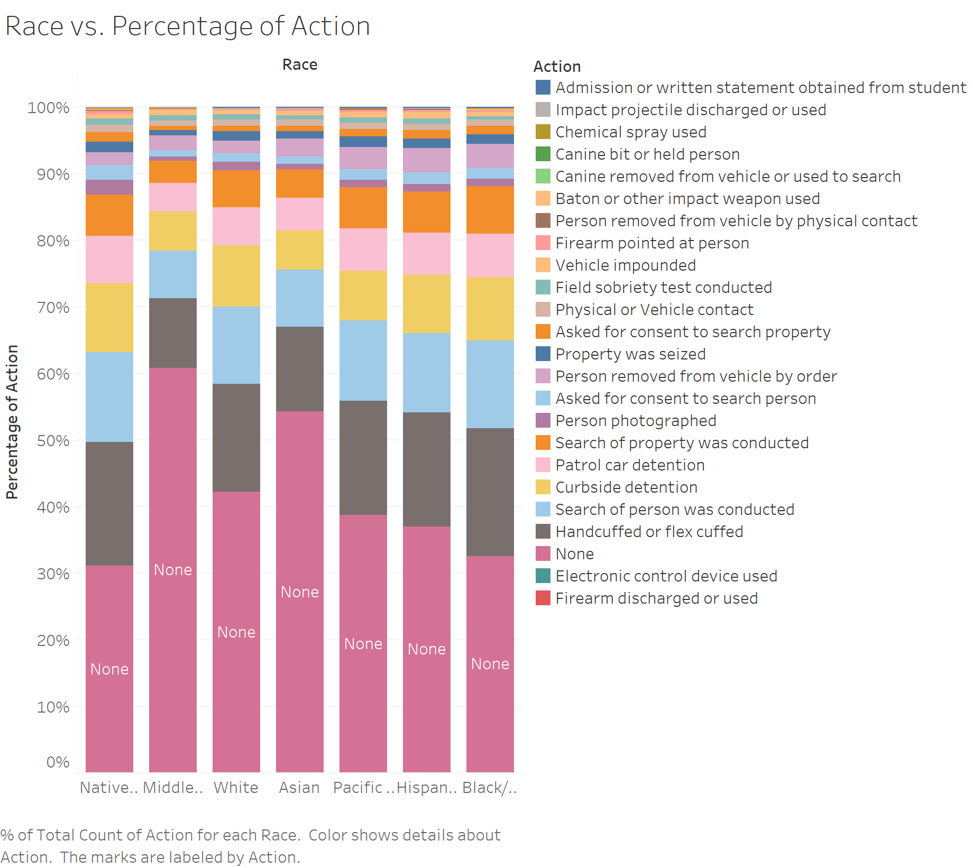

* Fig 2 shows the most common action is none action, and is handcuffed or flex cuffed, asked for consent to search person, curbside detention, patrol car detention, and search of property was conducted respectively for most of the population.
* Fig 2 shows middle eastern or south Asian have the highest non-action proportion, and the Native American and Black/African American have the lowest non-action proportion.
* Fig 2 shows Black/African American and Native American have the highest proportion of being handcuffed or flex cuffed.

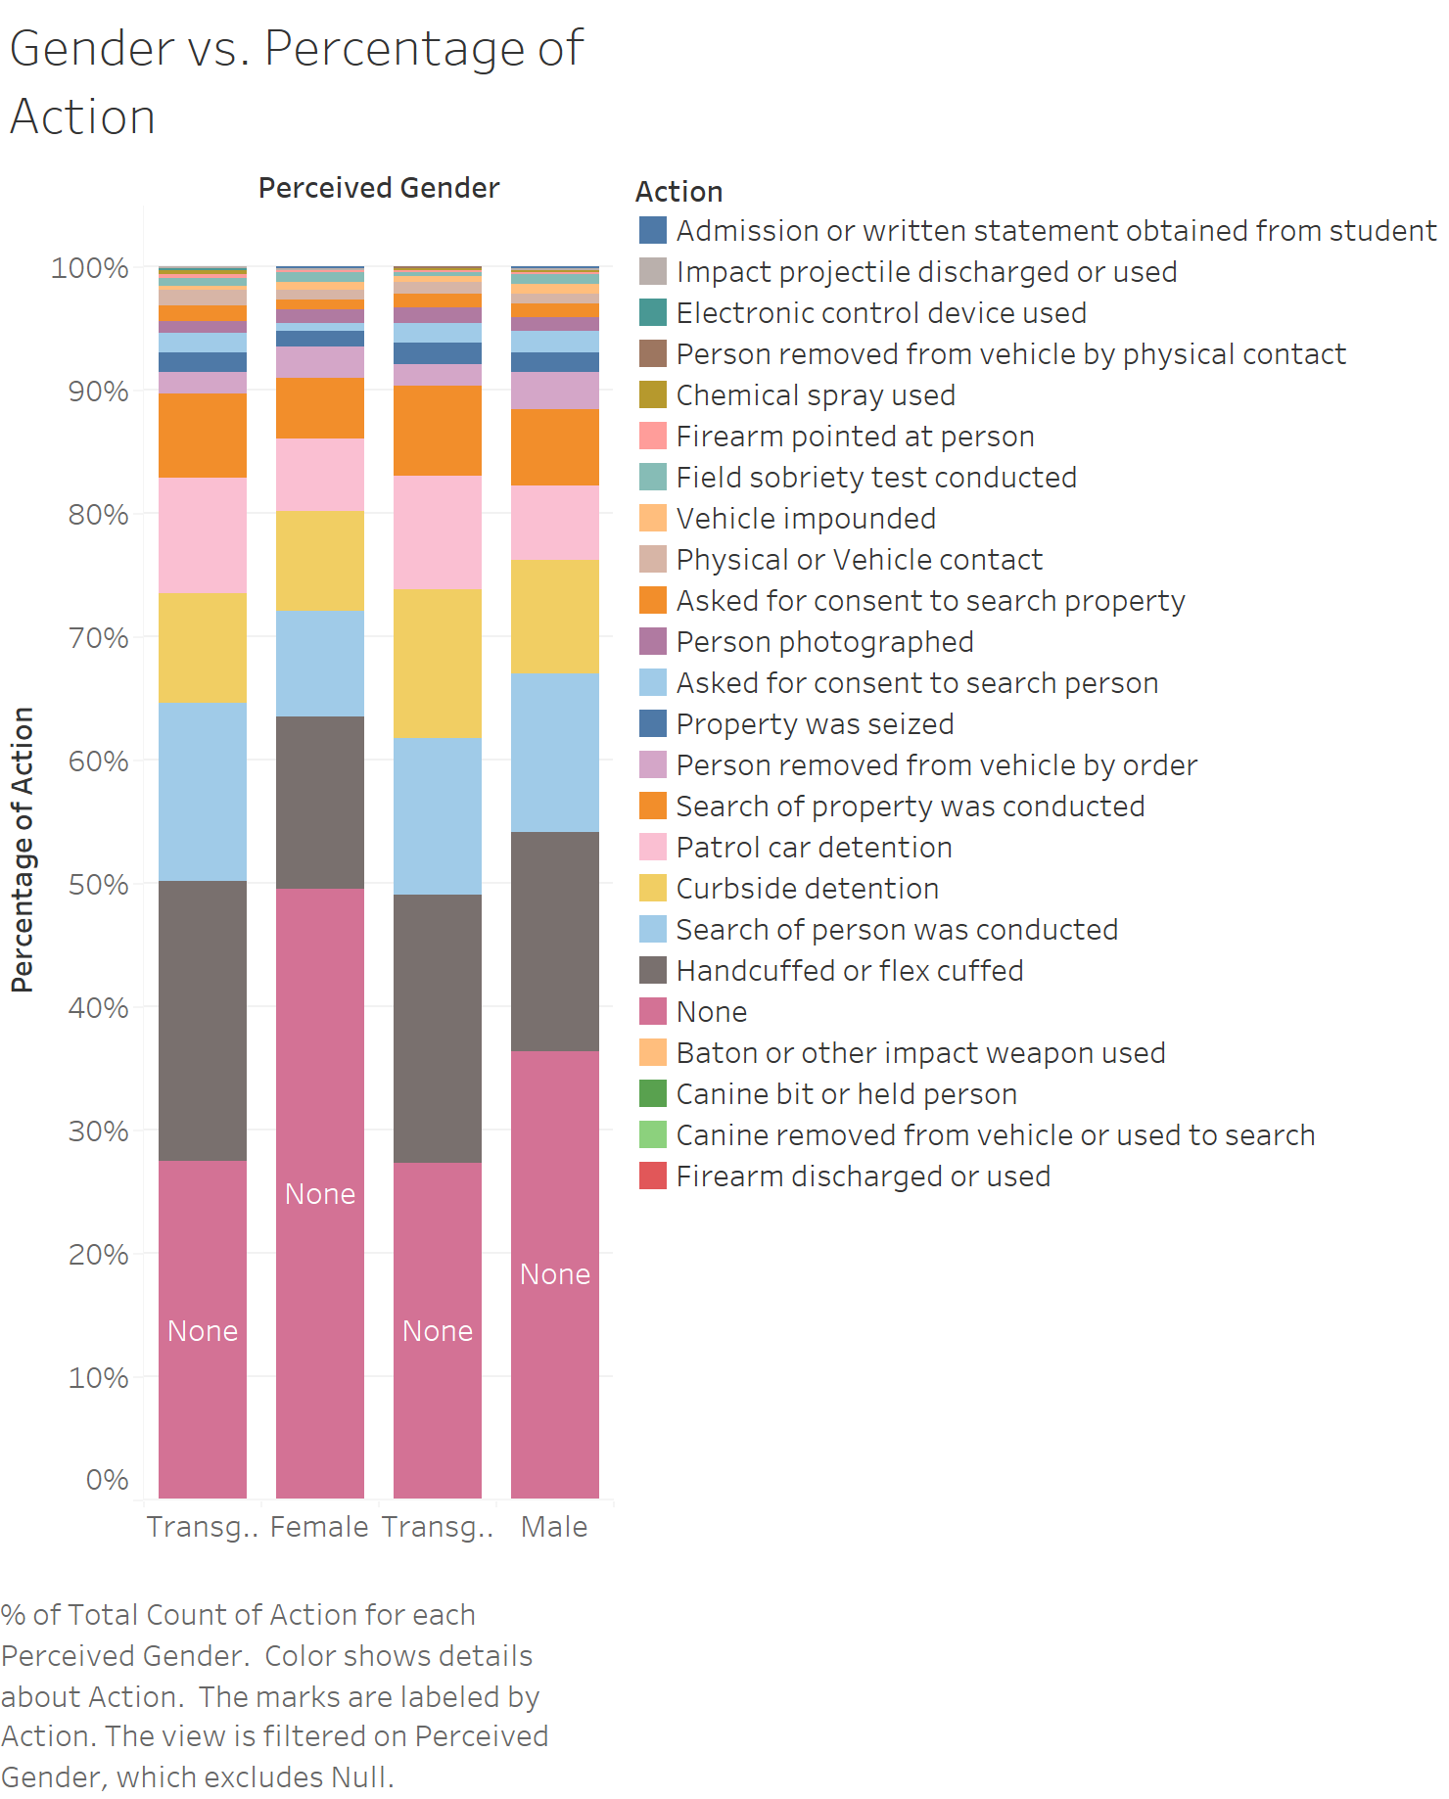

* Fig 3 shows transgender people are less likely to have none action, and famale have the highest proportion of none action.

**Implication**

* Outliers in Fig1.1 might be the results of a small sample size of officers with 37 and 50 years of experience.
* If we remove the outliers in Fig1.1, there would be a weak negative correlation between stop duration and experiences of officers.
* Officer with more than 35 years tends to assign only the binary sex identity to people.
* People who are perceived as transgender tends to be stopped for lonegr.
* In terms of race, Asian and Middle-Eastern and Southern Asian are more likely to be freed from the stops while others, Black and Native American are more likely to be interfered.
* In terms of perceived gender, female are more likely to be freed from the stops while transgender are more frequently to be interfered.